DEPLOYING AN APPLICATION ON ELASTIC BEANSTALK

Step 1: Open Elastic Beanstalk.

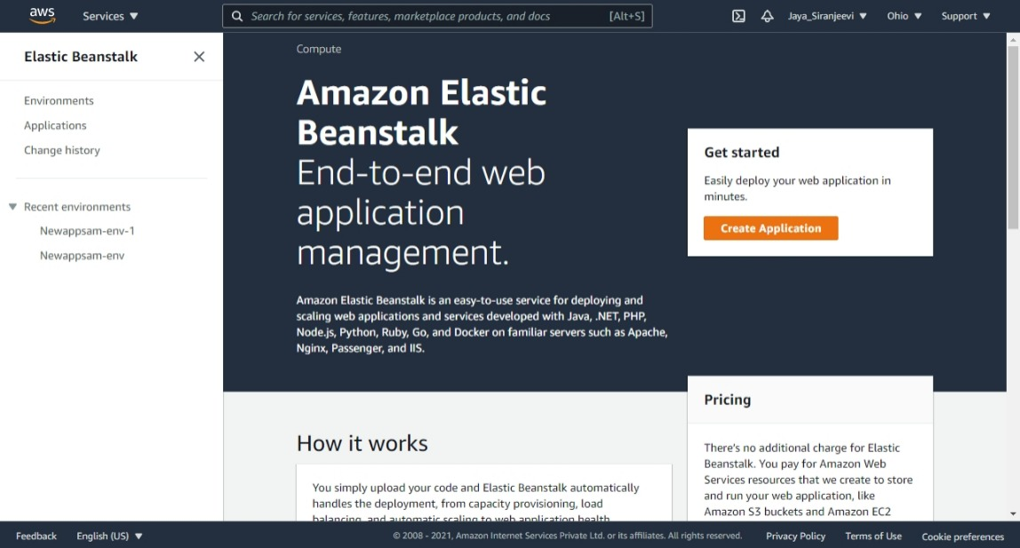

Step 2: Click on Application from menu and Create an Application.

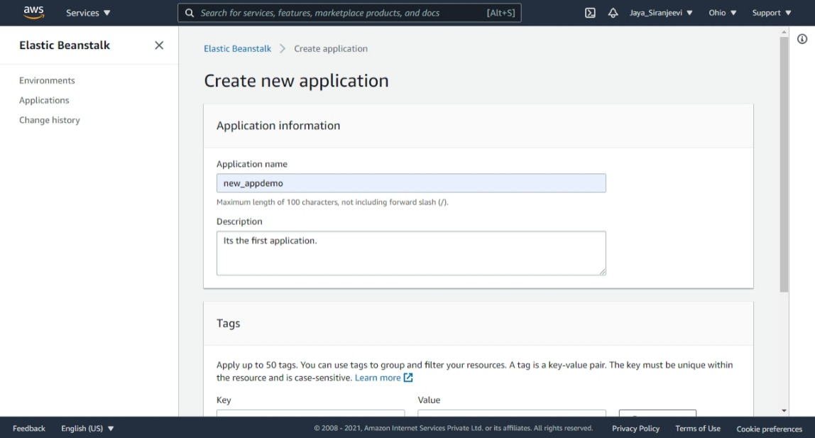

The application created successfully.

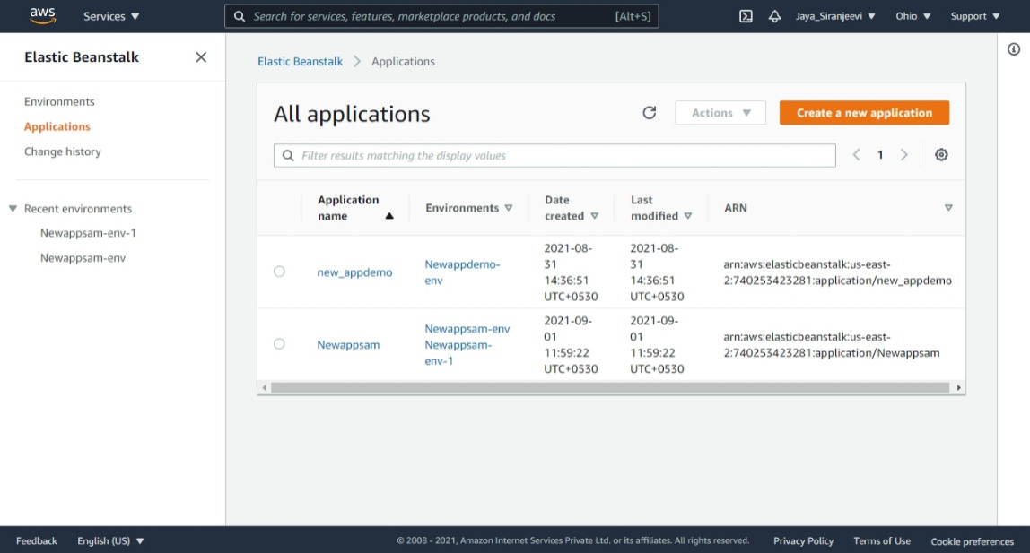

Step 3: Now create a new Environment.

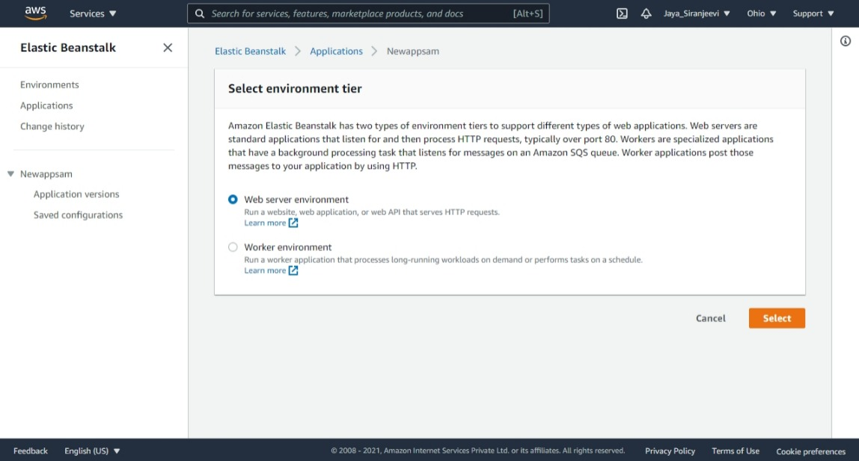

Step 4: Choose the platform to work on & deploy the sample application / Upload the Code.

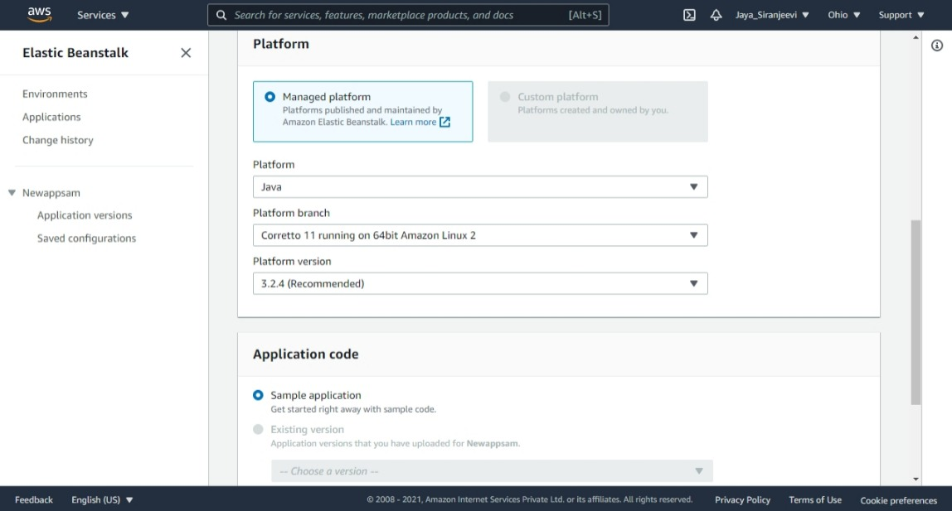

The Environment is created.

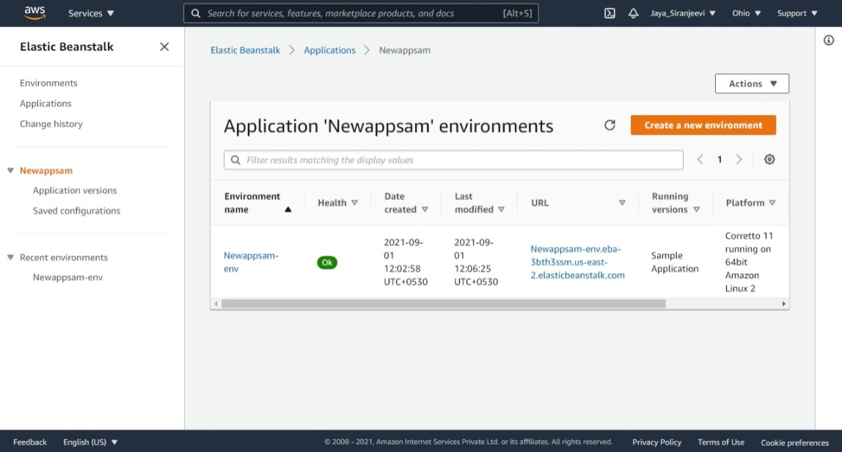

Here, two environments are created. First is on the platform Java and second is on Python.

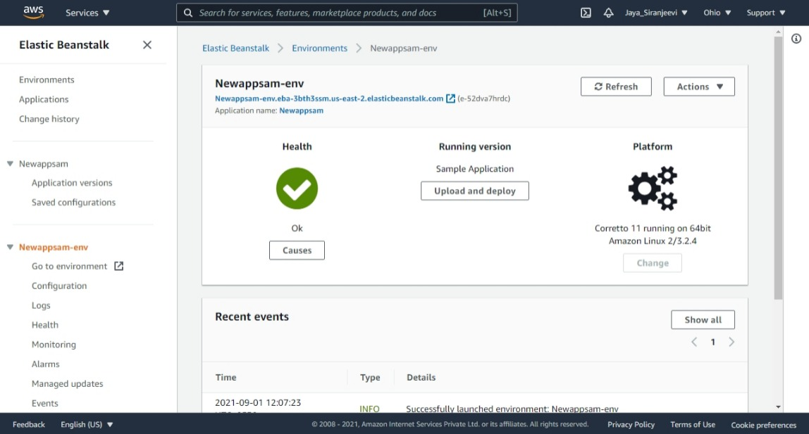

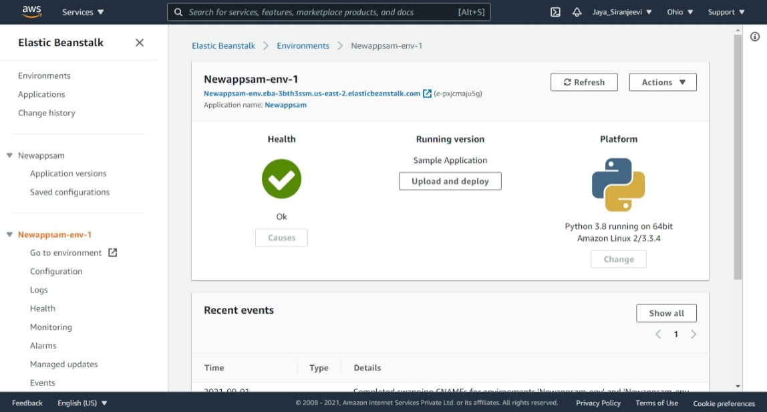

Step 5: The application ‘Newappsam’ has two environments namely ‘Newappsam-env, Newappsam-env-1’.

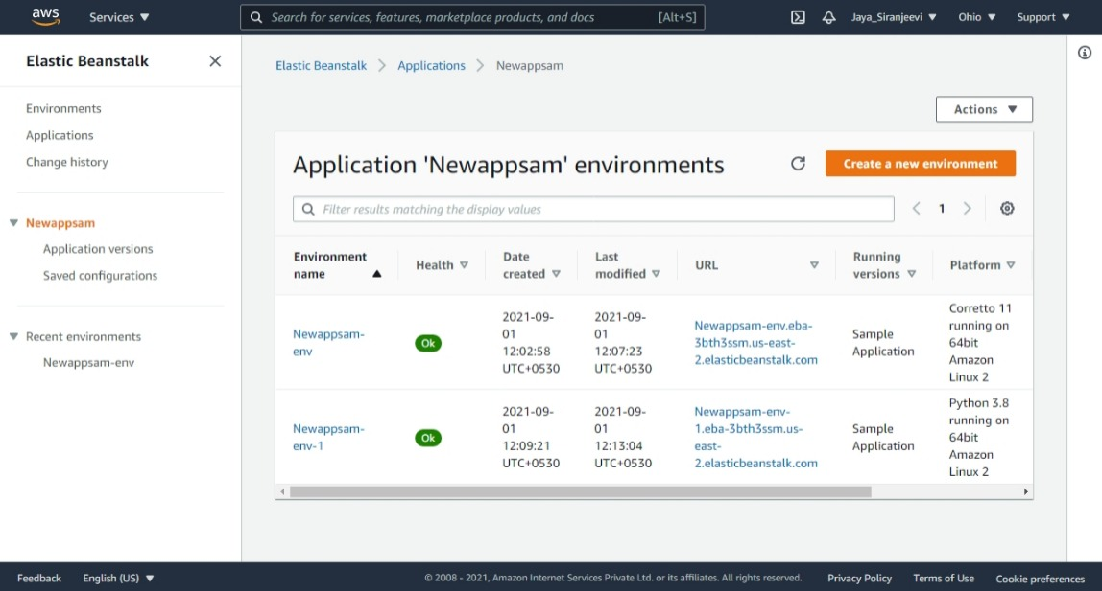

If needed the environments can be also swapped.

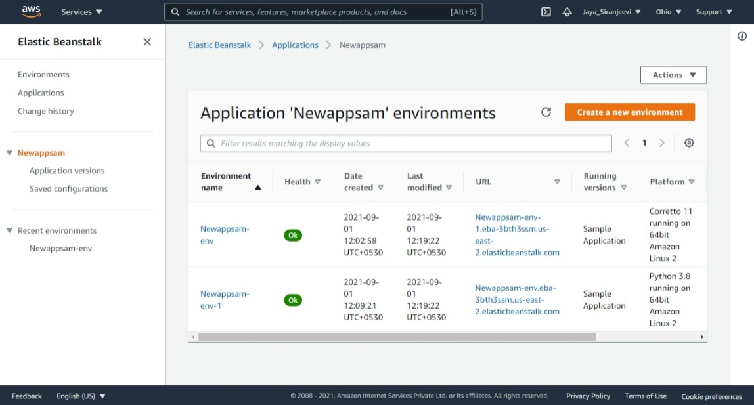

Environment 1: Java.



Environment 2: Python.

